The Legend of Chris Kyle.

The deadliest sniper in U.S. history performed near miracles on the battlefield. Then he had to come home.
~ By Michael J. Monney from D Magazine APR 2013
There’s a story about Chris Kyle: on a cold January morning in 2010, he pulled into a gas station somewhere along Highway 67, south of Dallas. He was driving hi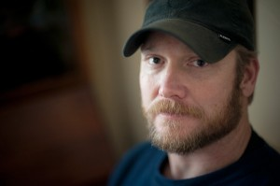s supercharged black Ford F350 outfitted with black rims and oversize knobby mudding tires. Kyle had replaced the Ford logo on the grill with a small chrome skull, similar to the Punisher emblem from the Marvel Comics series, and added a riot-ready aftermarket grill guard bearing the words ROAD ARMOR. He had just left the Navy and moved back to Texas.
Two guys approached him with pistols and demanded his money and the keys to his truck. With his hands in the air, he sized up which man seemed most confident with his gun.
Kyle knew what confidence with a gun looked like. He was the deadliest sniper in American history. He had at least 160 confirmed kills by the Pentagon’s count, but by his own count—and the accounts of his Navy SEAL teammates—the number was closer to twice that. In his four tours of duty in Iraq, Kyle earned two Silver Stars and five Bronze Stars with Valor. He survived six IED attacks, three gunshot wounds, two helicopter crashes, and more surgeries than he could remember. He was known among his SEAL brethren as The Legend and to his enemies as al-Shaitan, “the devil.”
He told the robbers that he just needed to reach back into the truck to get the keys. He turned around and reached under his winter coat instead, into his waistband. With his right hand, he grabbed his Colt 1911. He fired two shots under his left armpit, hitting the first man twice in the chest. Then he turned slightly and fired two more times, hitting the second man twice in the chest. Both men fell dead.
The entire article and more may be found in the April, 2013 issue of "D magizne" just place this URL into your web browser and check it out: http://bit.ly/YZmgsQ

