In May of 1964, I was an Air Force Pilot in Vietnam flying a mission in a single engine fighter-bomber. The F-105-D Thunder Chief was fondly called “Thud.” It was my first jet assignment after flight training, and I loved the machine.
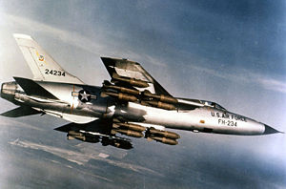

It was around 0900 local time when I had released some bombs and was reasonably sure that I had hit the target when the cockpit suddenly filled with smoke, and I started to feel the heat of a fire that was burning close to my body. I didn’t think twice or hesitate, I went through the procedure that I had gone over and over in my mind day and night even when I slept. I punched out. A million things went racing through my mind. I remember thinking that at least I’m not going too fast. I noticed my speed was a few knots less that 300 when I departed. It seemed that I was instantly under the big green canopy of the parachute that saved my life and only a few hundred feet above a small field that contained a grouping of small trees and bushes near a little white building. There were irrigated rice patties on three sides, and a road that passed along the north end. I wasn’t more than twenty miles south of Hanoi.

After I was safely under the canopy of my parachute, I noticed the airplane continuing past me a couple miles before it hit the ground and exploded into flames. There was plenty of fuel aboard. There were a few bombs left, I’m honestly not sure about the number of remaining bombs. But, I did witness the impact, and I remember thinking how grateful that I was that my Uncle Sam had provided me an escape from a fiery death. Everything worked as advertised. Now, I started to pray to Almighty God for help because my situation was not the best. I prayed for someone to be close by that would come and pluck me out of this very uncomfortable predicament.

I hit the ground in good shape. My helmet was intact, but I had a large knot on my forehead, and my left arm was hurting a little. I gathered up the parachute and headed for the clump of bushes. So far, so good, but I could see a NVA or VC or someone that didn’t look too friendly snooping around and looking in my direction. My adrenal glands were working overtime as I was scared to death. The ambient temp was in the high nineties, and I was shivering like I was freezing to death. “Dear Lord God, please help me get out of here. I don’t want to be captured.” I was in a constant state of prayer.

I got on my hand held radio and was desperately trying to get someone to answer. Finally someone answered, “Settle down son, we hear you. Can you give me your coordinates?”

I wasn’t all that sure of anything, but I told him where I had just dropped my bombs, and that I was less than 5 miles Southeast of the target. He requested my name and my ID code. “Danny Hill, and my ID code is 57 Chevy,” I spouted still trembling.

“That checks out son. We have a Navy chopper within ten minutes of you. I’ll check and see if he can come get you.” The voice seemed like he didn’t care that there were bad guys approaching me from the North, and all I had was my government issued 45 with an extra clip of ammo. I could see myself trying to fight off several VC with a pistol that I never did get the hang of shooting with. I could hit a target if it were close, and I mean really close.

“Please tell the rescue chopper to hurry. There are bad guys close looking for me and they are sure to find me soon.” They had been firing their AK’s into the trees where I was hunching down trying to make myself invisible. I could hear the rounds hitting the trees only inches from where I was hiding.

“Hell son, tell the rescue chopper yourself he is on your frequency. He will answer to Jolly Green,” the voice stated with a slow West Virginia accent.
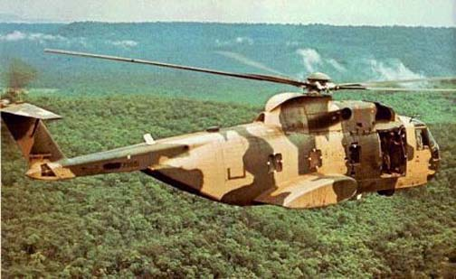
“Jolly Green, Jolly Green this is Dan, over!” No answer. I called again, “Jolly Green, Jolly Green this is Dan, over!” Still no answer!

“Patience son, he should be in range any minute,” the voice calmly stated. In the mean time I am scared to death, and I’ve already peed in my flight suit.

“Jolly Green, Jolly Green this is Dan, over!” Desperation is the only word that comes near to describing the way I was feeling.

“Okay, Dan, I can hear you but you are going to have to help me pin-point your position. Okay?” I remember that this pilot sounded like he was from Boston. It’s weird what I remember remembering.

“Okay, Jolly Green, I’ll do the best that I can. I’m in a field sort of like a pasture. On the north of the field, there is a road and guys are shooting from the road in my direction. I don’t think they know for sure that I am here yet. But they will figure it out soon enough. Please hurry. There is a small, white hut just west of the clump of trees and bushes that I’m hiding in. On the other three sides of this pasture are nothing but irrigated rice paddies. Which direction are you approaching from? Oh! I think I see and can hear you coming. Are you approaching from the west? If that’s you then you are headed in my direction.”

“Okay Dan, you are looking at us. We are approaching from the west, and I see the clump of trees and the little white shack. The bad guys with rifles are shooting toward us now. I’ll be hovering just south of you in less than a minute. You come a running, you hear. I don’t want to get my airplane shot up. Okay?”

“Don’t worry Jolly Green, I’ll be all out as fast as I can in your direction. I’ll be the guy wearing the slightly soiled, olive-colored jumpsuit and a white helmet on my head.” My voice still quivering.

I planned to meet the chopper before he could stop moving, but he stopped and was headed in a westerly direction about fifty yards from my hiding place. It seemed as if I was in slow motion. It felt like I could count to ten between each step as I was running as fast as I could, but everything was moving so slow. I was totally exhausted when I finally arrived, and I desperately needed someone to help me up and into the chopper but the only person to meet me was a large black man. He was very dark which made his clenched teeth and the white of his eyes stand out. He was firing a machine gun over me and in the direction of the road, and at the same time, was yelling at me to get my ass onboard and to hurry up. The guys from the road, and were now closer, were having target-practice with their AK’s on the Jolly Green Chopper.

Somehow, by the grace of God I managed to climb safely aboard the Jolly. Actually, I think there was another crewmember that dragged my butt aboard. I collapsed hardly able to catch my breath as the jolly lifted higher and accelerated to the west. The Black man continued to fire the machine gun in the direction of the bad guys until he ran out of ammo.

After a brief rest and catching my breath, I thanked the gunner and the pilot who sounded Bostonian along with the rest of the crew. They each risked their lives to save mine. I seemed to be unable to express just how thankful that I was for them coming to help me. My prayers had been answered. I was safe and within twenty minutes we were landing on the deck of an Aircraft Carrier somewhere in the Tonkin Gulf.

Believe it or not after climbing out of the Jolly, I was met by a herd of UPI reporters along with a film crew. The wanted my name and where I was from and what kind of airplane I was flying and all about the rescue. Everyone including Officers on the Carrier promised that my wife or first of kin would be notified long before this story was released to the media. Wrong! The first thing my wife said when I talked to her two days later was that she saw me on the 6PM news the day before.
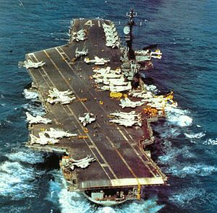

This is a true story. The names are not correct because I don’t remember them. I heard this story from the rescued pilot while I was hanging out with a bunch of other pilots in the late seventies. We were all parked at a place called DAL JET located on Dallas Love Field. We were all listening to this fellow pilot tell his war story that had taken place ten years earlier.

I asked him what he would do different if he could do it over again. And he said: “I would NEVER, NEVER, EVER get any slower than five-hundred-knots in enemy territory.” He claims that he was shot down by small arms fire because he was flying slow and sight-seeing after dropping some of his bomb load. He reiterated, “The best thing to do is drop your load and get the hell out of there as fast as you can go. Don’t even worry about fuel, there will be a tanker once you get in a safer environment. Just get the hell out of Dodge as fast as you can!” ~Adverse Yaw

